
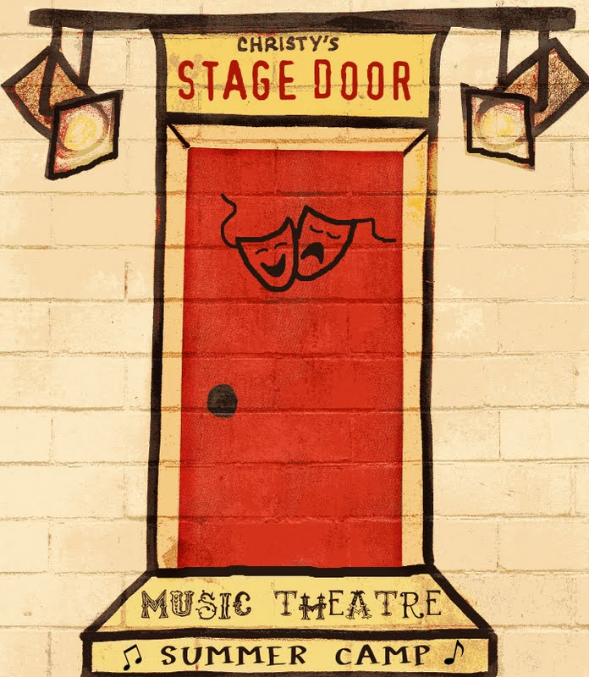
Christy’s Stage Door March Break Camp
at the Harmony Centre for youth ages 8-14
Sunday March 15 – Thursday March 18, 2015 9:00am – 4:00pm
(no camp on Friday March 19, 2015)

Today’s Date: _____________________
Student name: ______________________________________________ *Students must be between the ages of 8-14
Second student: _____________________________________________

Date of birth (D.O.B.) Month/Day/Year _________________________
Date of birth (D.O.B.) Month/Day/Year _________________________
Parent or Guardian’s Name(s) (first) _______________________ (last) _________________________________
(first) _______________________ (last) _________________________________
Address: ___________________________________________________________ (Postal Code) _________________

Phone: (Home) ______________________ (Work) __________________________ (Cell) ________________________
Parent/Guardian Email: ______________________________________
Student Email: ______________________________________________

Does your child have any health or behavioural concerns we should be aware of to make their time with us safe and enjoyable for all? Please ensure all allergies are listed.

In case of emergency, please ensure your child has their OHIP card on their person at all times during classes.

Emergency contact name & phone number: __________________________________________________________

Cost:
1st child OSLT Members $185 Non-Members $200
2nd child 10% discount OSLT Members $166.50 Non-Members $180
Please consider purchasing a youth membership ($16.95) for your child or a family membership ($79.10) covering parents and all school-aged children living in the home.

Credit card #__________________________________________ Expiry Date _________ 3-digit security code: _____
Name on card: ____________________________________________________________
Date charged ___________ Auth # ________ initial _____



Christy’s Stage Door March Break Camp
at the Harmony Centre for youth ages 8-14

Sunday March 15 – Thursday March 18, 2015 9:00am – 4:00pm
(no camp on Friday March 19, 2015)

Parent/Guardian Information Form

Please keep this page for your records
- Classes are 9:00 am - 4:00 pm Sunday March 15 – Thursday March 18, 2015. The camp will take place at the Harmony Centre, one block east of the Roxy, as OSLT is hosting the Western Ontario Drama League at the same time.
- There will be a half hour break at noon and two 15 minute nutrition breaks.
- Please send your child with a bagged lunch and two nutritional snacks. The instructor requests that children are sent with water in labeled containers. No juice please.
- Please ensure your child has their OHIP card on their person throughout the course.
- We require a minimum of 15 participants for the course to run. There is a maximum of 25 participants.
- Deadline for registration is March 9, 2015.
- Should you have an emergency and need to reach your child during classroom time, please try the following numbers in the following order: Box office: 519 371 2833 Administrative office: 519 371 3425

Christy Taylor has a dedicated following in Grey and Bruce Counties. An established professional performer and teacher, Christy’s courses establish an atmosphere where expansion of a child's expression can take place. In this energetic and creative teaching environment, she encourages students of all ages to explore the world around them, to express their own uniqueness and feelings of self-worth in a safe environment.
The fundamental goal of this course is to assist in the personal, cultural and social development of young people through the practice of theatre, empowering them to develop their own artistic voice under the mentorship of professional artists and educators.
This course usually sells out with a waiting list, so we encourage you to book early, on or before the deadline of March 9, 2015.

