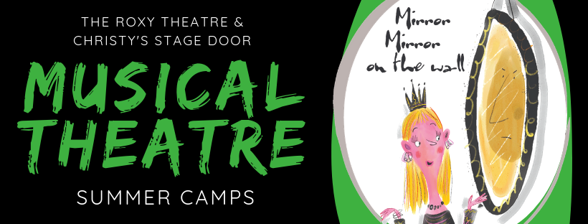
Junior Camp – ages 7-11- July 1-12, 2019
Senior Camp – ages 12-18 – July 15-26, 2019
Join us at The Roxy Theatre this July for our fun-filled musical theatre camps! This year we will be staging Roald Dahl’s twisted musical adaptation of Snow White & The Seven Dwarfs.
Throughout the camp, students will learn songs, choreography and staging, and work on character development and vocal techniques for solos and chorus singing. These camps are perfect for all levels of experience, and end with two performances.
Camp Information for parents and guardians
- Classes are 9am-4pm, Monday to Friday for both the Junior and Senior camps.
- The performances are ticketed shows open to the public; show times are 2pm & 6pm.
- Please send your child with a nut-free, bagged lunch and nutritional snacks. The instructor requests no juice, pop, power drinks, or high-sugar foods.
- Please ensure your child wears comfortable clothing and shoes and has their OHIP card with them in case of emergency.
- There will be two 15-minute breaks and a one-hour lunch break.
- The registration deadline is June 21, 2019.

STUDENT NAME, AGE AND BIRTHDATE:
2ND STUDENT NAME, AGE AND BIRTHDATE:
PARENT/GUARDIAN NAME(S):
ADDRESS:
PHONE NUMBERS (HOME, CELL, WORK):
EMAIL ADDRESS:
ADDITIONAL EMERGENCY CONTACT NAME AND PHONE:
Does your child have any health or behavioral concerns we should be aware of to make their time with us safe and enjoyable for all? Please ensure all allergies are listed.
JUNIOR CAMP SENIOR CAMP

Camp Cost: $355/student 2nd Child Discount: $320/student
Payment can be made at the box office, by phone (519-371-2833) or on our website. Please email the completed registration form to boxoffice@roxytheatre.ca or drop it off at our box office.

ROXY THEATRE and CHRISTY’S STAGE DOOR YOUTH THEATRE SUMMER PROGRAM

Parent/Child Participation Agreement Form

Welcome!

It is our intention to provide a fun, safe and high quality musical theatre training experience for your child(ren). In order to do this it is important that we work together towards this end. The summer camp program is a unique opportunity for the youth of our community to work in a professionally designed training environment developing the skills and confidence to be the greatest theatrical version of themselves while supporting each other and working as a team.

Everyone will be on stage and part of the ensemble with a few of them being cast in one of the
lead roles. Everyone will be an integral part of the story telling!The amount of work involved in producing a live theatre show in two weeks is staggering. It relies on full participation and regular attendance for the two weeks. It also usually requires minimal assistance from parents/guardians for the assemblance of our costume needs. We are deeply appreciative for the help provided from those who can.

Please read through the following and sign your acceptance of these conditions. If you believe
you will have any conflicts please discuss them with us before signing or registering your
child(ren).

Rules of participation:
- I agree to pay for the two weeks prior to the first day of camp and will submit a fully completed registration form.
- I agree to ensure my child attends each day. I will make arrangements with Christy (program director) prior to any unavoidable absenteeism. [Missing more than 3 rehearsals will result in the cast member being removed from any scenes or songs that are affected by their absence].
- I will get my child to camp each day on time and pick them up promptly. My child will attend each scheduled performance.
- Should I be more than 15 minutes late in picking up my child, I will pay a $10 cash staff fee for the extra supervision.
- The first day of camp is the only day that we have to hold auditions both informal and formal. If my child cannot be in attendance that day, I agree that they will therefore not be considered for any of the lead acting/singing roles.
- I agree that the Roxy Theatre and/or Christy’s Stage Door may use pictures of my child, without compensation, for promotional purposes on social media and printed materials.
- I agree that if my child exhibits inappropriate or destructive behaviour, and if this behaviour persists to the extent that it is disruptive to the rehearsal process, my child will have to be removed from the program forfeiting any refund. (Once the program begins we cannot accept anyone else and we usually have a waiting list. Disruptive behaviour or refusal to participate prevents the rehearsal from progressing and we only have 7 days to complete the show. The other three days include a day of auditions and 2 tech rehearsal days).

DATE:
PARENT/GUARDIAN SIGNATURE:
CHILD SIGNATURE:
2ND CHILD SIGNATURE:

