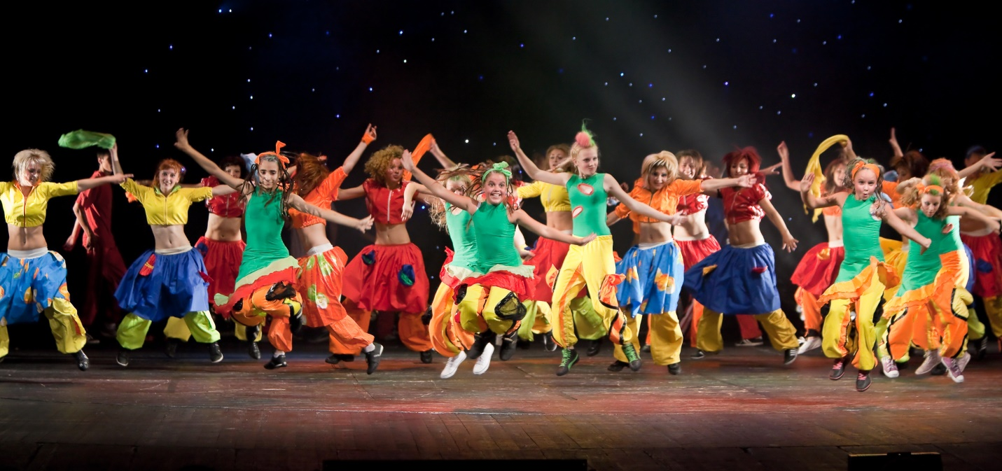

Join us at The Roxy Theatre this March Break
for a fun-filled week of theatre, music and dance!

- Led by Christy Taylor, this five-day camp is designed for youth aged 8-15 and takes place on the Roxy stage where you will:
  - Sing and Act
  - Learn scenes, monologues and skits
  - Explore your creative side and discover your talents

This camp is a great preparatory course for our popular summer camps, where students participate in full-scale musical productions.

Parent/Guardian Information Form

- Classes are 9am-4pm Monday, March 13 to Friday, March 17, 2017.
- Please send your child with a bagged lunch and nutritional snacks. The instructor requests that children bring water, rather than juice, pop, power drinks, or high-sugar junk food, please.
- Please ensure your child has their OHIP card on their person throughout the course.
- We require at least 15 participants, with a maximum of 20.
Spots book quickly – please register soon!

Today’s Date: ______________________
Student name and Age: __________________________________________________
Second student and Age: _________________________________________________

*Students must be between the ages of 8-15
Parent or Guardian’s Name(s): ____________________________________________________
Address: ______________________________________________________________________

Phone: Home ___________________ Work ___________________ Cell ___________________
Parent/Guardian Email: ______________________ Student Email: ______________________

Does your child have any health or behavioural concerns we should be aware of to make their time with us safe and enjoyable for all? Please ensure all allergies are listed.

In case of emergency, please ensure your child has their OHIP card with them each day.

Emergency contact name & phone number: _________________________________________
Camp Cost: $185 for OSLT youth members, $200 for non-members
2nd child discount: OSLT Members $166.50 Non-Members $180
Please consider purchasing a youth membership for your child or a family membership covering parents and all school-aged children living in the home.
Youth membership: $15 + HST = $16.95 Family membership: $115 + HST = $129.95
Credit Card #: __________________________ Expiry Date: _____________ Card Type: ______
Three-digit security code: ________ Name on card: _________________________________
Date charged: __________________ Processed by: __________________________________

